DABRAS II Guide
Qizhi Zhang (qzhang@anl.gov),
Jeffery R. Anton, Gerald A. Letizia, Mark Sreniawski
Argonne National Laboratory
July 31, 2016

Software Design and Features
- User Interface and Action Control
The design idea for this software is to encapsulate all DABRAS functions and features under one main framework.
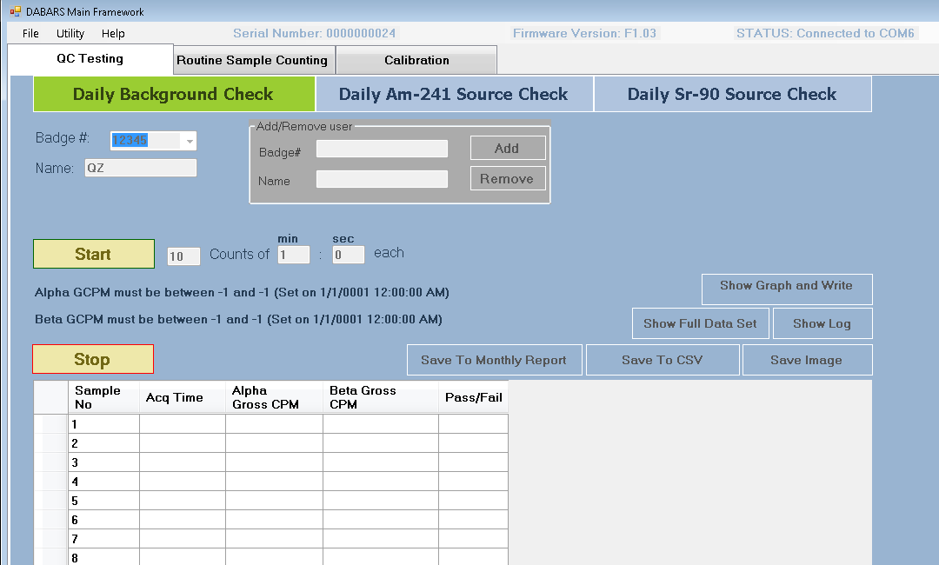

As shown in the above picture, the main framework has a top menu ribbon with three menu items: File, Utility and Help, and DABRAS connection status information. The Utility menu has features to manage connection/disconnection to the device’s serial port, setting building# and set#, resetting administrator password and logout administrator (as seen in the pictures below).
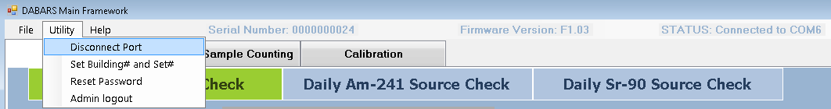
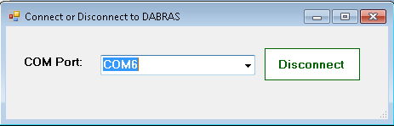
Right below the menu ribbon, there are three function tabs: QC Testing (activated and highlighted with white color in the picture), Routine Sample Counting and Calibration. Each of these function tabs encapsulates its own categorized functions and features that will be described in more details later.
The application also manages the action flow between the function tabs and within each tab. At the very first run of the application, there is no configuration file or calibration data yet. The application will automatically create needed folders with files and subfolders for data storage purposes, including the configuration file with default data. The picture below shows that the folder named “dabras_deployFolder” initially had only the application file “DABRAS_Software.exe”. After started the application by double-clicking, three folders will have been created.
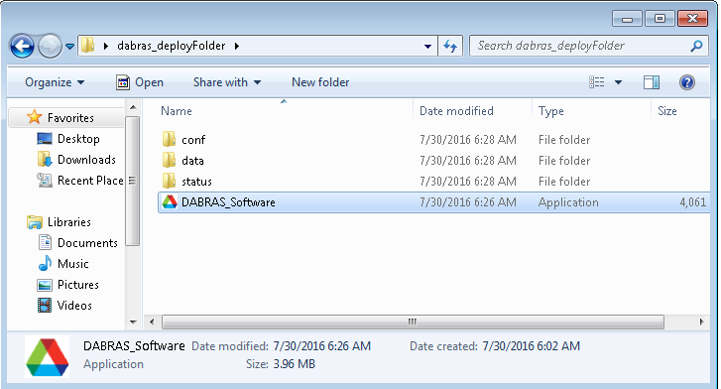

Then, the application will try to make connection to the default serial port. If a connection is successfully made, it will check if there is any up to date calibration data available. If it finds that the calibration is out of date, it will suggest you to perform the calibration first unless you have the administrator privilege to skip the calibration.
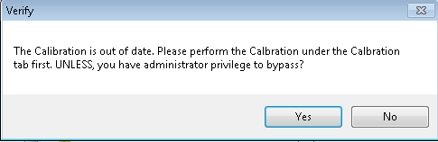

You can click “Yes” to use the outdated calibration for testing, or you don’t want to skip calibration by clicking “No”. Clicking “Yes” will get you an authenticating window to ask for administrator’s password (by default, it is set to “admin_pass” without quotes). Clicking “No” will send you to the QC Testing tab with no action allowed, so you will have to click on the “Calibration” tab to perform calibration. To do so, you will be presented with the authenticating window to log in as the administrator.
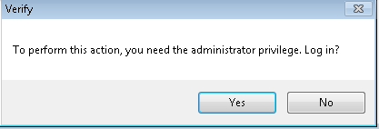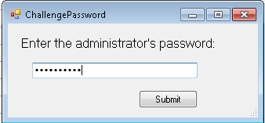

In addition to controlling access to the Calibration tab actions, the authenticating also guards resetting the administrator password, defining the building# and the device set# within “Utility” from the menu ribbon, selecting the background type within the Routine Sample Counting tab.

- Underlying Data Structure
The previous data structure for managing data flow and data storage was a flat data array with each array item containing information of a radioactive source, which had limited the management of data and source to a single key-the serial number (or name) of the resource. That structure not only forced each source to carry redundant radionuclide family data, but also did not facilitate the source management within radionuclide families.
The current data structure has a hierarchy that contains radioactive sources within their own radionuclide family. So radioactive sources can share characteristic properties of their family simply by carrying the information of a “family ID”, yet still have their own unique properties (data). All the radionuclide family specific information is stored in a radionuclide family object, and information such as “most current source” can be updated as soon as any family member is tested and has newly modified property data.
This change of underlying data structure not only satisfies the user requirement to have the source and family aligned with the physics reality, but also makes the radioactive source management feature seamlessly integrated with other functions. The changes made to any source or family under the Source Management feature, are immediately applied to the other parts (Calibration, QC Testing and Routine Sample Counting) of the application.
In addition to changes made under the Source Management, any modification made through Utility menus; within Calibration tab( with updated efficiency scanning/counting results, high voltage setting and automatically/manually set HiLo Alpha and Beta limits); and within QC Testing tab (with new daily counting results) is immediately reflected throughout the application.
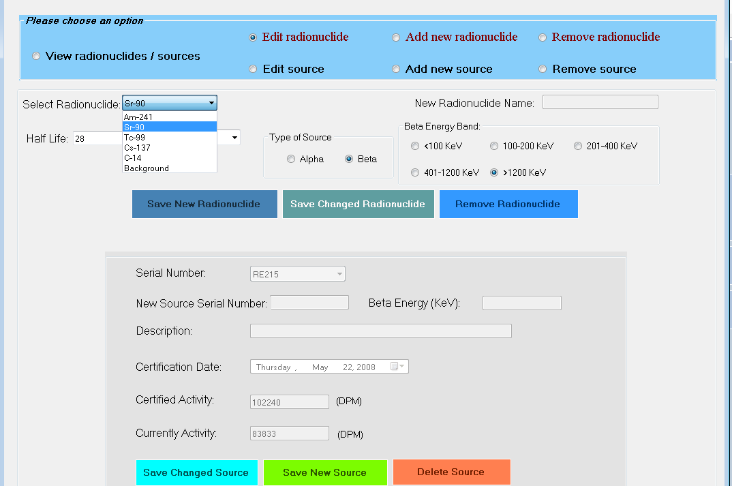

- Features

  - Calibration Tab
More details to come (Jeff & Jerry: please help flesh out!)

  - QC Testing
More details to come (Jeff & Jerry: please help flesh out!)

  - Routine Sample Counting
More details to come (Mark: please help flesh out!)

Installation
There is only ONE file that is necessary to run the DABRASII application from scratch--DABRAS_Software.exe
To install, please simply copy or download this file (from the given source location) to your designated folder, for example, “C:\Users\qzhang\dabras_deployFolder\”. Then from where you have just installed the application file, double click on the file to start it.
Note: you don't need to download any other file in order to run the DABRAS II application. Of course, you should not need Microsoft Visual Studio to run it at all.
If it is the first time this application is run from this location, you will get a popup window telling that a configuration file is missing and the application will create one for you. In addition to create the configuration (and its host folder ‘conf’), the application will also create two more folders: ‘data’ and ‘status’, with each of them containing files and/or subfolders with files. These folders are created to store the DABRAS II testing results.

